- Project Title: HR Analytics dashboard using python,PostgreSQL and powerBI
- Shubham mali
- Technologies used:
- Python (pandas, Matplotlib), PostgreSQL, and PowerBI

- Executive Summary
This project focuses on analyzing employee attrition data to identify key factors affecting employee turnover. The analysis was performed using Python for data cleaning and exploratory data analysis, PostgreSQL for structured querying, and Power BI for interactive dashboard visualization. The goal of this project is to help management make data-driven decisions to reduce attrition.

Problem Statement
The organization is experiencing high employee attrition, which increases hiring and training costs. There is a need to analyze employee data to identify patterns and key factors responsible for attrition.

Objectives
- To calculate total employee count and attrition rate
- To analyze department-wise attrition
- To evaluate the impact of salary and job role on attrition
- To build an interactive dashboard for management insights

Dataset Information
- Total Records: (1473 rows)
- Total Columns: (38 columns)
- Missing Data: 57 values in YearsWithcurrManger column
- Important Columns:
  - Age
  - Department
  - Job Role
  - Monthly Income
  - Attrition
  - Years at Company

Tools & Technologies Used

Python
- Pandas (Data Cleaning)
- Matplotlib (Visualization)

PostgreSQL
- Data storage
- Aggregation queries
- Group By analysis

Power BI
- KPI Cards
- Bar Charts
- Pie Charts
- Slicers & Filters

Data Cleaning & Preprocessing
- Checked for missing values
- Removed duplicate records
- Converted data types where necessary
- Handled categorical variables

Exploratory Data Analysis (EDA)

We beagan with data preparation and cleaning in Python

- Data Loading : Imported the dataset using pandas.

- Initial Exploration : Used hr.info() to check structure and .describe() for summary statistics

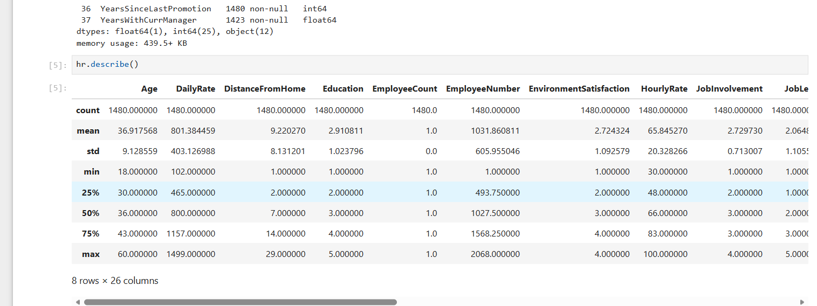
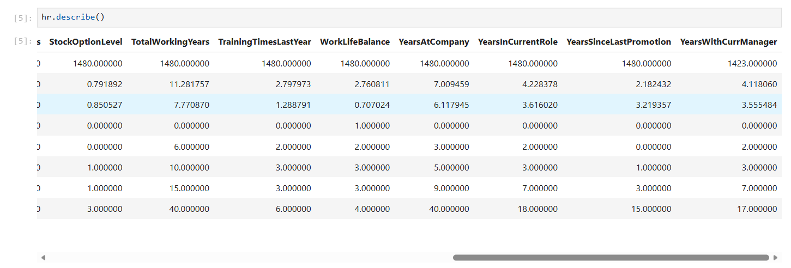
- Missing Data Handling : Checked for null values and imputed missing values in the YearsWithcurrmanager column using the median
- Column Standardization : Renamed columns to snake case for better readability and documentation.
- Database Intergration : Connected Python script to PostgreSQL and loaded the cleaned DataFrame into the database for SQL analysis.

4. Data Analysis using SQL (Hr Attrition)
We performed structured analysis in PostgreSQL to answer key business questions:
- Total employees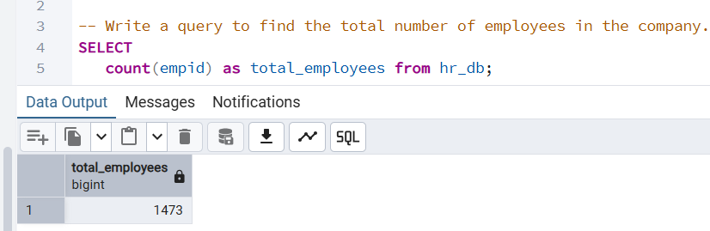
- Employees left the company
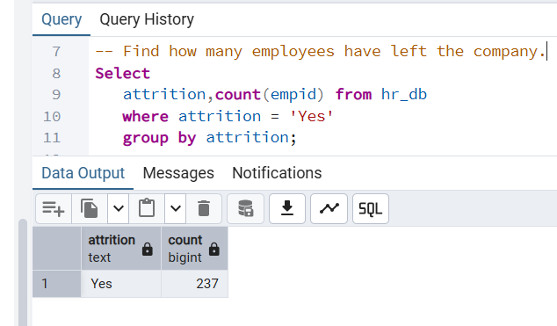
- Total employees in each department
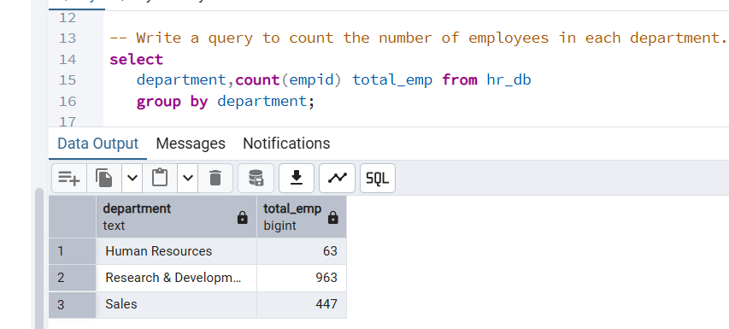
- Total employees left company in each department
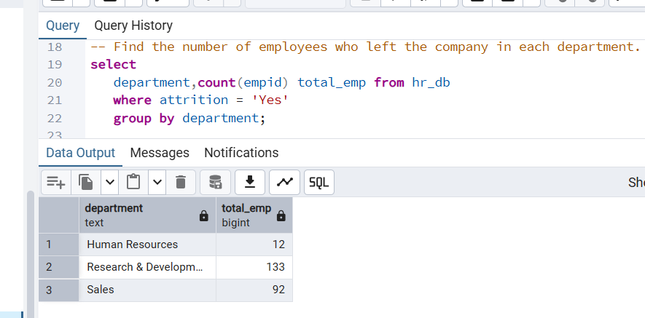
- Avg income each job role
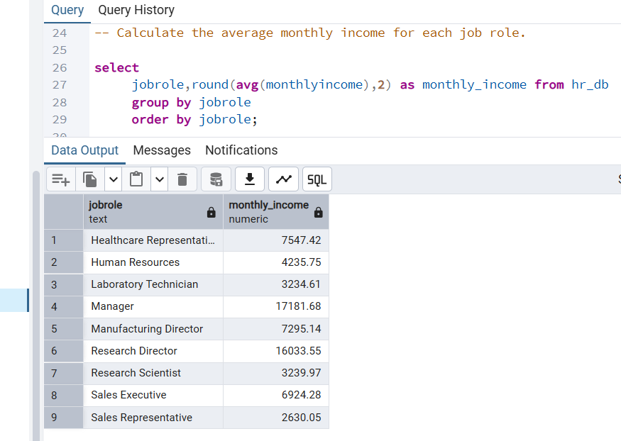
- Attrition by age_group

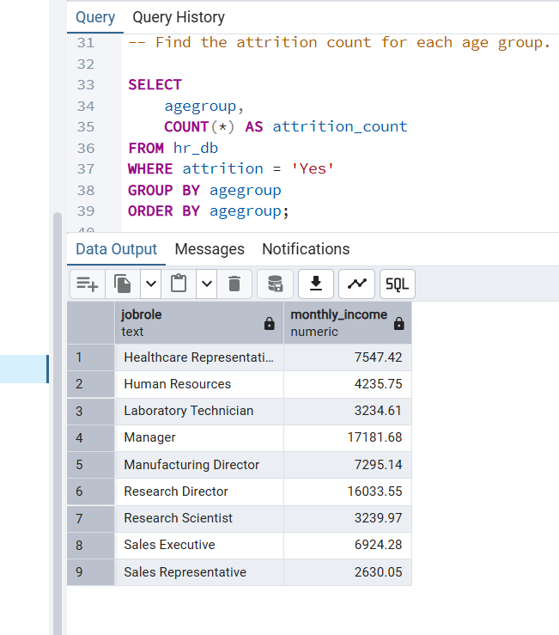

7.Highest income
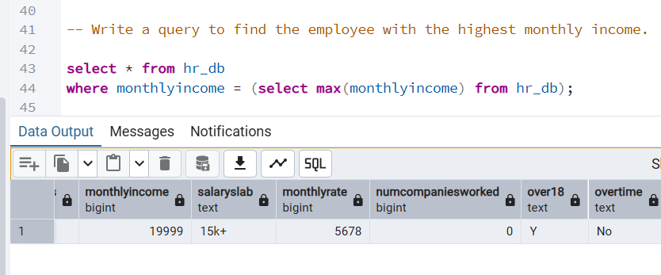
8.Average monthly income based on total working years
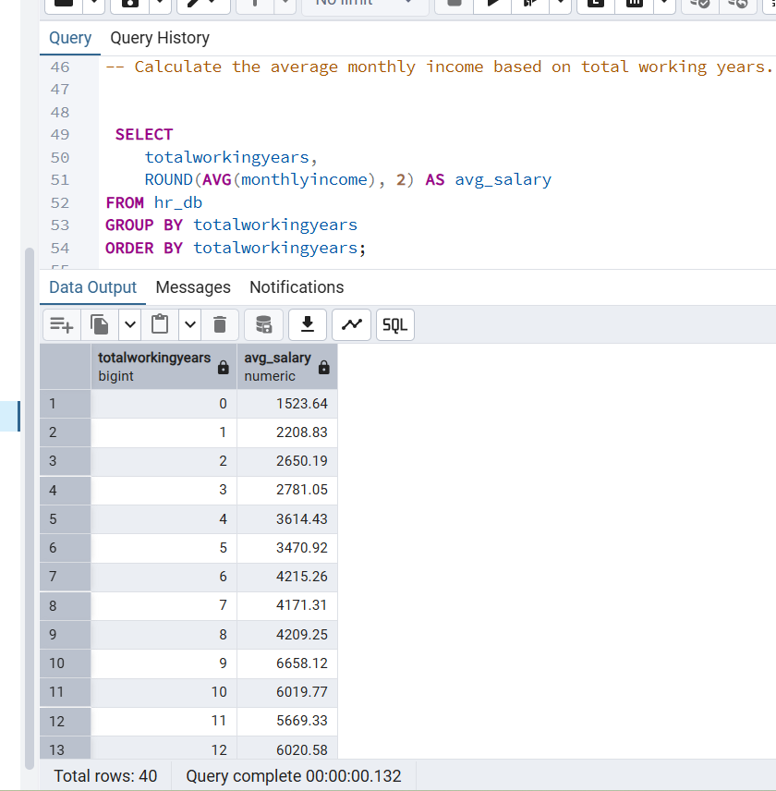

9 . Attrition percentage for each gender

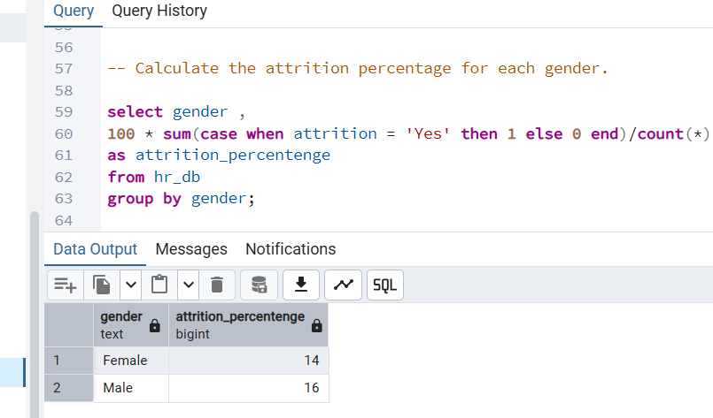

Power BI Dashboard Explanation
The dashboard includes:
- KPI Cards (Total Employees, Attrition Rate)
- Department-wise Attrition Bar Chart
- Salary Distribution Chart
- Interactive Slicers for filtering by Department and Job Role
Users can filter data dynamically to analyze trends across different categories.
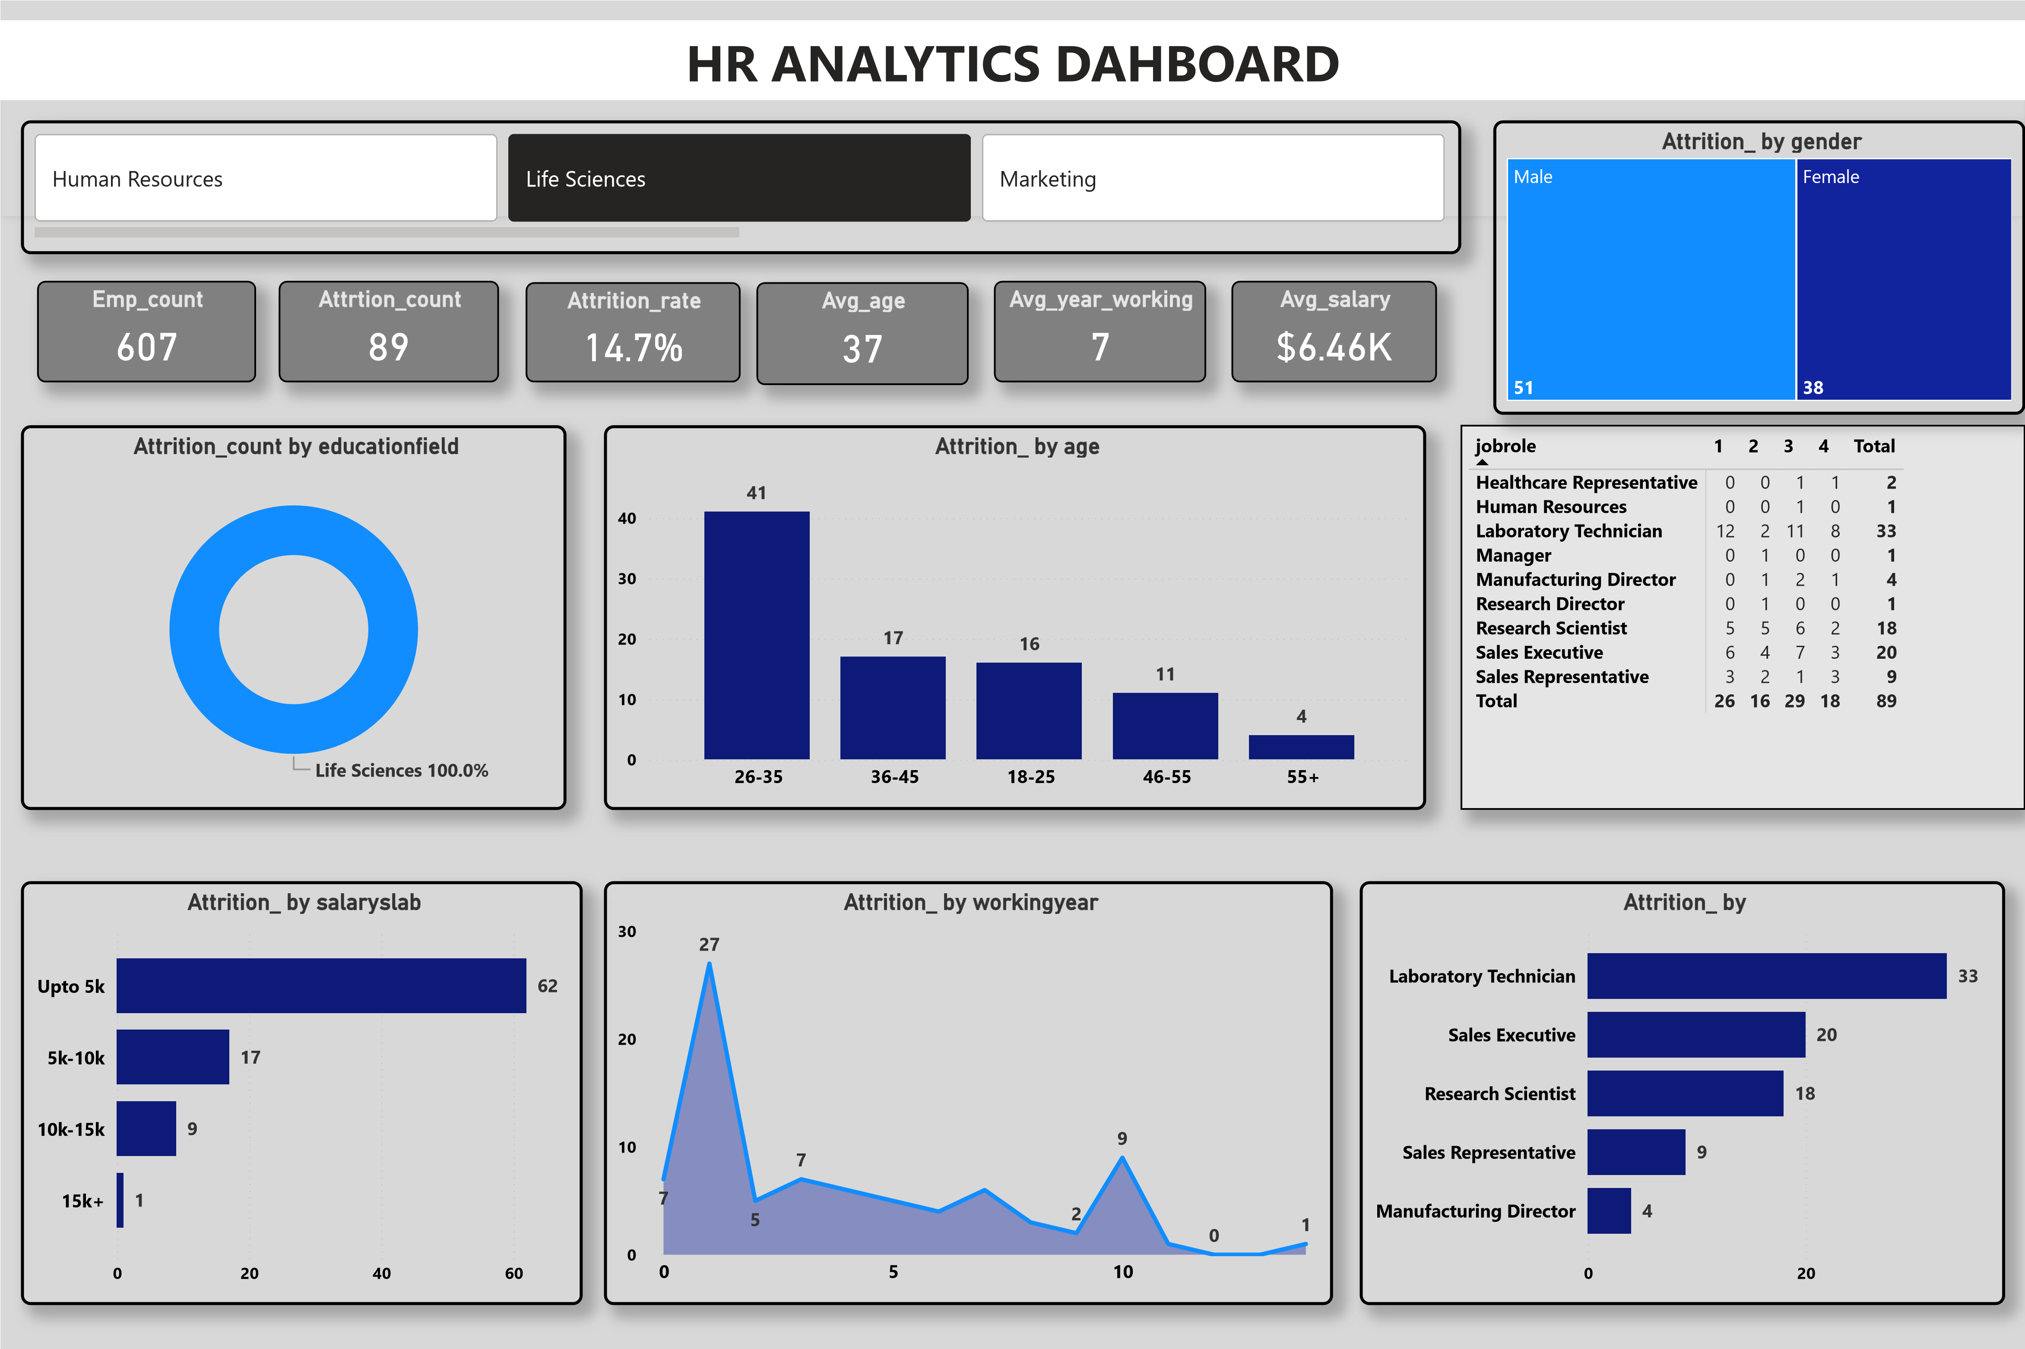

Key Insights
- Employees with lower salaries are more likely to leave.
- Sales department has the highest attrition rate.
- Employees working overtime show higher turnover.
- Employees with fewer years at the company have higher attrition.

Conclusion
The analysis provides valuable insights into factors affecting employee attrition. The dashboard enables management to monitor key HR metrics and make informed decisions to improve employee retention.

